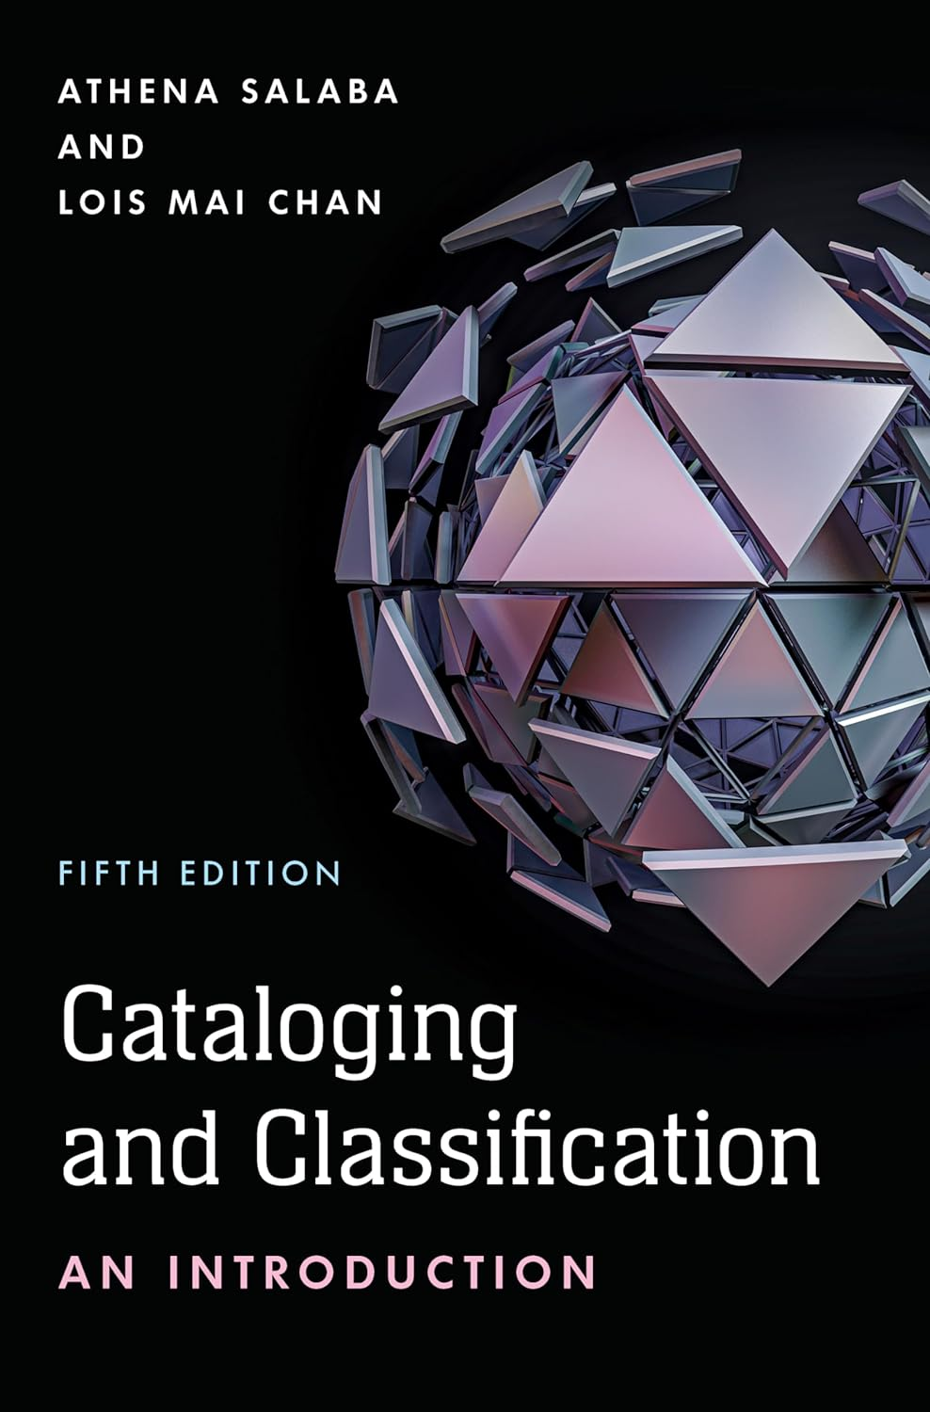

(image from Amazon) Required textbook

Spring semester 2025

**How to Contact me:**

Dr. Xinyu Cindy Yu Mills

Tel: 601-266-4238

Email: [xinyu.yu@usm.edu](mailto:xinyu.yu@usm.edu)

Office location: FGB 121

**Office hours: Monday & Tuesday 8:30am-1:30pm & Thursday 8:30-10:30am or by appointment**

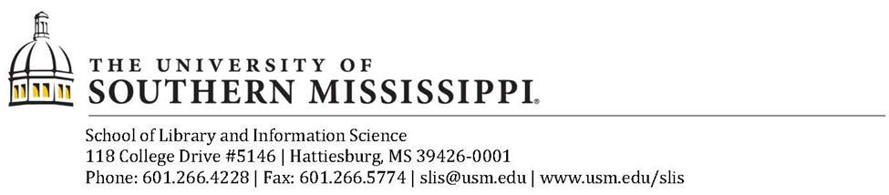

|  |  |
| --- | --- |
| **Calendar Date** | **Full Term** |
| Last day to add/drop without Academic/Financial  Penalty | Jan. 28 |
| Last day to receive 100% refund  (No tuition credit issued after this date) | Jan. 28 |
| Last day to drop classes without instructor permission | Jan. 28 |
| All approved drops will result in grade of W within these dates | Jan. 29 – Apr. 8 |
| Last day to make an add/drop course request or withdraw from the University and receive a grade of W | Apr. 8 |

**Course Description/Overview:** This course is an introduction to cataloging and classification. We will explore basic principles and practices of library cataloging together with trends in the broader context. Through lectures, discussions, and exercises, we will learn how to use the standard methods to organize information in various environments. More specifically, our discussions, exercises and lectures will be focused on the applications of RDA (Resource Description and Access) rules with descriptive cataloging, bibliographic data exchange format, i.e., machine-readable catalog records (MARC), authority control, and metadata. The main goal of this course is to acquire a beginner’s level of knowledge regarding cataloging applications and tools.

**Catalog Description:** Principles and methods of cataloging and classifying library resources.  Provides practice in bibliographical description and subject analysis.

**Course Learning Outcome**

|  |  |  |
| --- | --- | --- |
| **Cataloging and Metadata Core Competencies (ALA Core 2023 5A, 5B, 5C, 5D & AASL 4.2)** | **Student Learning Outcomes** | **Assessments** |
| Understand the principles, systems, trends, and goals involved in the  organization and representation of recorded knowledge and information | -Students demonstrate an understanding of cataloging principles and practices | -Discussion 1-3 Cataloging evolution, Marc identification, and subject vocabulary terms; |
| Implement the developmental, descriptive, analytical, and evaluative skills needed to organize recorded knowledge and information | - Students apply and implement cataloging standards and data across the various cataloging methods | Exercises 1-5: Practices of Descriptive cataloging, Encode and MARC and RDA; Quiz 1-Descriptive Cataloging Overview |
| use evaluation criteria and selection tools to develop, curate, organize, and manage a collection designed to meet the diverse curricular and personal needs of the learning community.(AASL 4.2) | -Students learn to use professional cataloging tools and technology to evaluate and organize information | Exercise 4-8 |
| Maintain the systems of cataloging, collection, metadata, indexing, and classification standards and structures, and implement methods used to apply, create, and discover recorded knowledge and information, and the weaknesses and strengths of these systems | Students understand methods of subject access | -Exercise 6-8; LCSH, LCC, & Dewey; Quiz 2 subject cataloging |
| Recognize the ways that cultural biases impact and influence the collection and description of recorded knowledge and information | Students discuss the ethical and cultural implications of cataloging and organization of information | -Discussion 4 |

See the SLIS Graduate Handbook for student responsibilities, university and school policies.<https://www.usm.edu/library-information-science/slis_grad_handbook_2022_23.pdf>

**Required Texts:**

Salaba, A. & Chan, L. M. (2023). *Cataloging and classification (5th ed*). Lanham, MD: Rowman & Littlefield. ISBN: 978-1-5381-3291-0(paperback); ISBN:978-1-5381-3293-7(electronic)

**Class sessions** (Weekly Class Meeting at Zoom Classroom in Canvas):

Wednesdays 6:30-7:59pm Central Time

To access the course content from Canvas: <https://usm.instructure.com/login/canvas>

These times are Central Time – if you live in another time zone, adjust accordingly. Interactive class sessions are held each week unless otherwise notified.

**The first session, an introductory class, will be held in Zoom live classroom (in Canvas) on **January 22** Wedsday at 6:30 pm Central time. To access (classroom is scheduled weekly) **Join URL**: <https://usm-edu.zoom.us/j/88485419814>

**Course Prerequisite(s)**: None

**Number of Credit Hours**: 3  
**Nature of Course:** Required for MLIS; required for Class AA licensure in library science (Mississippi Class AA level licensure).

**Nature of Students: Graduate**  
**Format of Course: Online**, weekly sessions, semester in length.



**Course Generally Scheduled/Offered:** Fall, Spring and Summer semesters.

**Course Support:**

* Student success: <https://www.usm.edu/student-success/>
* Required technology includes reliable Internet or Wi-Fi connection and Microsoft Office 365 (free for students at www.usm.edu/itech/microsoft-office-365)
* For tech support such as mobile apps, go to www.usm.edu/itech/student-hot-sheet
* Course materials are available at Canvas(usm.instructure.com): – login with SOAR ID and password
* Canvas support: <https://online-learning.usm.edu/canvas-technical-assistance/>
* Student help: <https://www.usm.edu/student-help/index.php>

**Online Learning Guidelines**

Course materials are on Canvas at http://usm.instructure.com. Students are expected to 1) check their university email account each day, 2) check **Canvas** each day to review the course’s learning module and assignments, 3) read and post to the discussion board, and 4) meet in the virtual classroom (Zoom in Canvas) each week that is scheduled.

Communication is vital in an online environment, so please let me know if you see anything that is inconsistent or a dead link, if anything is not clear, or if you have any questions. SLIS faculty and staff want you to succeed so review How to Be a Successful Graduate Student.

**Policy on Attendance and Make-up Work:** Virtual classroom attendance and participation is expected. Participation is a large part of the grade and consists of the virtual classroom attendance/participation and discussion board postings. Students may make up for one class attendance by viewing the recorded session and sending a summary with their comments to the professor. Students are expected to post to each required discussion board; late postings will be accepted but may not earn full participation points; feel free to complete makeup work to earn credit.

**Course Tools and Resources**

**Tools available online without the use of password:**

MARC 21 Format for Bibliographic Data <http://www.loc.gov/marc/bibliographic/>

OCLC Bibliographic Formats and Standards <https://www.oclc.org/bibformats/en.html>

Library of Congress Authorities <http://authorities.loc.gov>

**The following online tools access will be provided by the instructor with passwords, which can be found in Canvas home and course modules.**

Worldshare [https://univofsouthernmississippi.share.worldcat.org/wms](https://nam12.safelinks.protection.outlook.com/?url=https%3A%2F%2Funivofsouthernmississippi.share.worldcat.org%2Fwms&data=05%7C02%7Cxinyu.yu%40usm.edu%7Cac97631155de4805063508dc38999b50%7C7f3da4be2722432ebfa764080d1eb1dc%7C0%7C0%7C638447479599689187%7CUnknown%7CTWFpbGZsb3d8eyJWIjoiMC4wLjAwMDAiLCJQIjoiV2luMzIiLCJBTiI6Ik1haWwiLCJXVCI6Mn0%3D%7C0%7C%7C%7C&sdata=%2Bp9Svz58wiFGnm9alntoy0aO3M1%2B9pgg6uRhA%2Bzs%2FmE%3D&reserved=0)

RDA Toolkit <http://access.rdatoolkit.org/>

WebDewey <http://connexion.oclc.org/>

Classification Web  [http://classificationweb.net](http://classificationweb.net/)

**Teaching Techniques/Methods Used in Course**: Class will be taught online with posted notes, assigned readings, and virtual classroom sessions. A discussion board for posting questions will be available.

**Major topics:** MARC record structure, descriptive Cataloging (areas of description, access points, and authority control and references), and subject Cataloging (classification-DDC and LCC, and subject headings), current developments in field of cataloging-FRBR and RDA, introduction to metadata, Semantic Web, linked data, and library discovery tools.

**Library Services**

The USM library provides services for online education students.  Please consult the information available at the following link: <http://libguides.lib.usm.edu/online_students>

**Teaching Techniques/Methods Used in Course:** Class will be taught online with posted notes, assigned readings, and virtual classroom sessions.  A discussion board for posting questions will be available.

**Major Topics**

* Purpose of Bibliographic control

Descriptive cataloging

* RDA rules and interpretations
* Areas of description
* Access Points and attributes
* Authority Control and cross references
* Metadata and cataloging developments

    Subject Cataloging

* Subject headings (LCSH, Sear’s list, MeSH)
* Classification - DDC and LCC

**Course Assignments:**

|  |  |  |  |  |
| --- | --- | --- | --- | --- |
| **Assignment** | **Due Date** | **Group/**  **Individual** | **Grading weight** | **Rubric** |
| Class exercises (8) | As assigned | Individual | credit given for turning in – 40% | Keys &rubric |
| Reading assignments (4) | As announced | Individual | 20% | Objective |
| Participation – (attendance and contribution) | Ongoing | Individual | 20% | Participation rubric |
| Quizzes (2)—Open book | As announced | Individual | 20% | Online |
| Total |  |  | 100% |  |

**Grading Policies and Calculation:**

Students may request, under extraordinary circumstances beyond the student’s control, an incomplete (I) if the majority of assignments have been successfully completed. A student who receives an incomplete will have only ONE semester in which to complete the work before the Incomplete turns automatically into an F. Students may also request a W (withdrawal) from the course. If this is the only class a student is taking, then the student must contact the USM Graduate School to properly withdraw.

**Points scale**:

**Course Expectations**

All assignments are due by the date indicated. Work not received on time may be graded as late (10% off) after 2nd day late (24-hour grace); no additional late points off but not accepted after 14 days without prior arrangement.

All written work is to be submitted through assignment links.  If you have difficulty accessing the course, please contact the instructor immediately or the ITech help desk.  If you submit your assignment some other way you run the risk of 1) my not receiving it, or 2) it not being graded in a timely manner.  Once you have attached your assignments for submission, you should click on the assignment to be sure that it is the CORRECT version.

Our class sessions are key for learning together. Therefore, please plan to attend all classes. If you have extenuating circumstances, please talk with me so we can find a good solution together. In general, sessions that are missed must be made up by submitting a written summary of all the chats held that week.  Prior arrangements should be made with the instructor for missing an interactive discussion if possible.  Additional unexcused absences result in a lower course grade.   
  
The calendar is a part of the syllabus but may be revised by the instructor as needed.  Additional instructions for assignments and grading rubrics are also considered a part of the syllabus.  
  
Students wishing to make up work because of illness or family emergency must provide external documentation before makeup arrangements can be made.

**Course Communication**

Communication between the professor and the students will be facilitated by way of e-mail, live classroom, and/or discussion board.  E-mail is used when private discussions are needed between the student and professor or between students.

**Note**: Please feel free to drop in or to set up a virtual appointment by contacting me. If these hours don't work for you, please let me know and we can find another time to meet. I generally respond within 24 hours. If you don’t get a response, please email me again after 2 days.

**Course Workload Statement**

Students are expected to invest considerable time outside of class in learning the material for this course. The expectation of the University of Southern Mississippi is that each week students should spend approximately 2-3 hours outside of class for every hour in class working on reading, assignments, studying, and other work for the course. For online classes, the average amount spent on a three-credit-course is roughly ten hours per week, including all assignments and interactions.

We realize that most students work and have family or other obligations. Time management is thus critical for student success. All students should assess their personal circumstances and talk with their advisors about the appropriate number of credit hours to take each term, keeping in mind that 30 credit hours each year are needed to graduate in four years. Resources for academic, technical, self-help, social, etc, can be found at [Student Help | The University of Southern Mississippi (usm.edu)](https://www.usm.edu/student-help/index.php)

**Academic Integrity Statement**

Academic misconduct involves deception to improve a grade, earn course credit, complete a degree, or create an unfair academic advantage for oneself or disadvantage to another in the academic community. All students at the University of Southern Mississippi should familiarize themselves with the Student Academic Integrity Policy to become familiar with what actions constitute academic misconduct, a violation of that policy. Southern Miss values “an approach to academics, research, and personal conduct based on integrity and civility” and the Student Academic Integrity Policy supports that University value. Forms of academic misconduct may include, but are not limited to:

· Cheating - Cheating is a broad category of academic misconduct characterized by an attempt to gain academic advantage through inappropriate means or impede the academic achievement of others.

· Plagiarism - The use of another person's or source’s words, creative works, or ideas without appropriate quotation or attribution; claiming or submitting for academic credit the work of another.

· Lying - The misrepresentation of one’s academic work, lying to an instructor to increase a grade, or lying to an instructor regarding an academic integrity violation.

· Acquiring or Distributing Information Inappropriately - The act of distributing or obtaining course assignments or examination questions or answers from sources not approved by the instructor or proctor (includes, but is not limited to, unauthorized use of the Internet, test banks associated with course text and previous student work).

· Fabrication or Falsification of Data - Any statement of untruth in any matters related to the academic experience, including but not limited to forgery; false claims of authorship; falsification of information, data, or results derived from or related to research or to laboratory experiments.

· Stealing or Defacing - The act of intentionally taking, transferring, defacing, or destroying, without right or permission, any property related to the academic mission of the University, including an attempt to impede others.

· Multiple Submissions - The submission, more than once, without authorization by any instructors involved, of substantial portions of the same work, including oral reports or work submitted for retaken courses.

· Conspiracy - The act of agreeing or planning with any person to commit any violation of the Student Academic Integrity Policy.

If you commit an act of academic misconduct, sanctions ranging from resubmission of work to course failure may occur to the possibility of receiving a grade of “XF” for the course, which will be on the student’s transcript with the notation “Failure due to academic misconduct.” Should you be accused of academic misconduct, please visit the Academic Integrity Website or email [integrity@usm.edu](mailto:integrity@usm.edu) for any questions you may have about your rights and about the academic integrity process. Southern Miss provides many campus resources that are detailed in this syllabus and will be discussed by your professors; please utilize those to help you learn. At Southern Miss, we care about your personal work and learning journey.

**Disabilities Statement:**

**Student Accessibility Services** (SAS)

SAS is Southern Miss’s designated office to assist the University in its commitment to protect the civil rights of students with disabilities. SAS protects students from discrimination and offers reasonable accommodations to give them equitable access to university courses and resources. Disabilities covered under the ADA may include but are not limited to ADHD, learning disabilities, psychiatric disabilities, physical disabilities, chronic health disorders, temporary injuries, and pregnancies. If a student feels that they need classroom or housing accommodations based on a disability they should contact SAS by phone at 601-266-5024, by email at [sas@usm.edu](mailto:sas@usm.edu) , in person by visiting the SAS office located in Bond Hall Room 114, or online at [www.usm.edu/sas](http://www.usm.edu/sas) .

**Mental Well-Being Statement**

USM recognizes that students sometimes experience challenges that make learning difficult. If you find that life stressors such as anxiety, depression, relationship problems, difficulty concentrating, alcohol/drug problems, or other stressful experiences are interfering with your academic or personal success, consider contacting Student Counseling Services (SCS) on campus at 601-266-4829. More information is also available at <https://www.usm.edu/student-counseling-services> , or [usm.edu/help](https://www.usm.edu/student-help/index.php). Student Counseling Services offers currently enrolled students free, confidential counseling services and can provide referrals to campus and community resources. Currently enrolled students living outside Mississippi can receive a one-time consultation to assure they are informed about available resources in their community.

*In the event of emergency, please call 911 or if there is a mental health crisis after business hours, contact the counselor-on-call at 601-606-HELP (4357), or call or text the National Suicide Hotline at 988.*

**Nondiscrimination Statement:**

The University of Southern Mississippi offers to all person's equal access to educational, programmatic and employment opportunities without regard to age, sex, sexual orientation, disability, pregnancy, gender identity, genetic information, religion, race, color, national origin, and/or veteran status pursuant to applicable state and federal law.

**Artificial Intelligence (AI) prohibit use**:

The use of generative Artificial Intelligence (AI) is not permitted in this class. Any use of AI tools for work in this class may be considered a violation of the University of Southern Mississippi's Academic Integrity policy.

The instructor of your course reserves the right to send any submitted work to AI detection software. The use of unauthorized AI tools will result in consequences deemed appropriate by the instructor and will be subject to the Academic Integrity Policy and the University of Southern Mississippi.

**USM Writing Center**

The Writing Center is a friendly space that provides free, individualized feedback and support to help Southern Miss students succeed with writing assignments for any class. The Center offers one-to-one consultations for any stage of the writing process, from understanding the assignment and brainstorming ideas to revising and editing. To make an appointment, visit usm.edu/writing-center. Select “Schedule an Appointment” and create a WCOnline account. The Writing Center is located in Cook Library 112, between Starbucks and the Speaking Center. For more information, visit usm.edu/writing-center or call the center at (601) 266-4821.

**Course evaluation**

You will be invited to evaluate the course at the end of the term. Please participate in this valuable process. I also invite your comments throughout the course and read all comments, suggestions, and recommendations.

**Course Activities Calendar**

**(**Subject to revision by the instructor**)**

(Unit # is listed in Canvas’s modules)

|  |  |  |  |
| --- | --- | --- | --- |
| **Class date** | ***Topic as in Modules (Canvas)*** | ***Read before the class*** | Assignments Due |
| **Wed 1/23** | Introduction to course and cataloging basics | Syllabus and course overview |  |
| **Wed 1/ 29** | Foundation of resource description | * Read Salaba Chapter 1&2 * Read “Introduction notes” in Unit 1 | Self-introduction due Jan 27 Monday midnight |
| **Wed 2/5** | Resource description and MARC format | * Read Salaba & Chan Chapter 3& 4, 17 (pp.563-564) * “Understanding MARC”[https://www.loc.gov/marc/umb](https://www.loc.gov/marc/umb/) * [What is a MARC record? (youtube.com)](https://www.youtube.com/watch?v=fdwF2Jf-RsY&t=209s) | Discussion #1 due Feb 3 Monday midnight  Exercise 1 due Feb 6 Thursday midnight |
| **Wed 2/12** | Access points& FRBR models, RDA rules, and core elements | * Read Salaba & Chan, Chapter 5& 6 | Discussion #2 due Feb 10 Monday midnight  Exercise 2 due Feb 13 Wed midnight |
| **Wed 2/19** | Resource description(Descriptive cataloging) Unit 2— | •Read Salaba & Chan Chapter 7&8 | Exercise 3 due Feb 20 Thursday midnight  Quiz 1 open |
| **Wed 2/26** | Resource description(Descriptive cataloging )Unit 2—  Authority control | * Read Salaba & Chan Chapters 8[Understanding MARC Authority Records: Machine-Readable Cataloging (loc.gov)](https://www.loc.gov/marc/uma/index.html) | Exercise 4 due Feb 27 Thursday midnight |
| **March 2-9** | Mardi Gras&Spring break | No Class Scheduled | No assignment due |
| **Wed 03/12** | Subject cataloging and analysis | Read Salaba &Chan 10 | Exercise 5(Authority control) due Mar 13 Thursday midnight |
| **Wed 03/19** | Subject headings (Unit 3)-Introduction and LCSH | Read Salaba &Chan chapters 11& 12 | Discussion# 3 due Monday 17 Monday midnight |
| **Wed 03/26** | Other subject headings and subject authority | No class scheduled(Instructor travels for conference) | Exercise 6 due March 26 Thursday midnight |
| **Wed 04/02** | Classification introduction(Unit 4) | Read Salaba &Chan chapters 13, 19 | Quiz 2 open |
| **Wed 4/9** | LCC | Read Salaba &Chan chapters 15, 16 | Discussion #4 due Monday April 7 Midnight |
| **Wed 4/16** | DDC | Read Salaba &Chan Chapter 14 | Exercise 7 due April 17 Thursday midnight |
| **Wed 4/23** | Future of cataloging | Read Salaba &Chan chapter 18 |  |
| **Wed 04/30** | No Class scheduled |  | Exercise 8 due May 1 Thursday midnight |

**Rubrics**

Participation Rubric

|  |  |  |  |  |
| --- | --- | --- | --- | --- |
| **Criteria/Levels** | **Excellent:**  **Consistent performance of all criteria;** | **Satisfactory:**  **Consistent performance of most criteria** | **Requires Improvement** | **Unacceptable** |
| Live class | Attends all required chats; is prepared to discuss and ask questions; contributes meaningful and unique ideas to discussions (90-100 points) | Attends all required chats; is prepared to discuss and ask questions; most contributions are unique and add to the discussion (80-89 points) | Misses one required chat or is not prepared for at least one chat or doesn’t always contribute to the discussion (70-79 points) | Misses more than one required chat or is usually not prepared for the chat or rarely or never contributes to the discussion (0-69 points) |

**Rubric for Discussions**

|  |  |  |  |  |
| --- | --- | --- | --- | --- |
| **Criteria/Levels** | **Excellent:**  **Consistent performance of all criteria – work that exceeds the expected level for graduate students** | **Satisfactory:**  **Consistent performance of most criteria** | **Requires Improvement** | **Unacceptable:**  **Fails to meet more than 3 criteria** |
| Assignment parameters/requirements (instructions) | meets all parameters(no late submission) | meets most parameters | fails to meet at least one parameter | fails to meet more than one parameter |

Rubric for Exercises

|  |  |  |  |  |
| --- | --- | --- | --- | --- |
| **Evaluation Areas** | **Excellent/very good (no deduction)**  (No or 1 error) | **Good**  (2 errors) 1-2 points off | **Fair**   (3-4 errors)  3-4 points off | **Unacceptable**   (5 or more errors) 5 points or more off or no point |
| Content/data | The assignment is completed as instructed; all fields are transcribed correctly. | The assignment is completed as instructed; all fields are transcribed correctly or with minimal errors. | The instruction is partially followed and transcribed with errors. | Transcription errors or do not turn in or plagiarized work |
| Structure (e.g.Capitalization, abbreviation & punctuation) | Properly follow the instructions. | Properly follow the instructions. | The instruction is partially followed and transcribed with errors. | No application or do not turn in or plagiarized work |
| Formatting (e.g. MARC) | All fields and subfields are properly coded | Minimal coding errors | Coding errors | Many coding errors, or do not turn in or plagiarized work |

Updated 01/17/2025